Guide – I2D2 Folder Structure
Under I2D2 the folders and the surveys were stored differently to the structure proposed by the Microdata Library.
Within a country, the first level is the year when a survey took place (or when it started if it takes place over more than a year) (see Figure 1).
Figure 1 - I2D2 Folder Structure
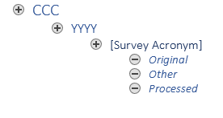
Within a year there you find the survey, identified by its acronym (for example LFS for a labour force survey, or HIES for a Household Income and Expenditure Survey). There can be several surveys in a single year.
Within a survey there are three folders: Original contains the original files. Sometimes you may find other ancillary information here (e.g., questionnaires or other blocks of the survey not used like a WASH module). Other should contain all other information, that is the questionnaires as well as intermediate output produced while creating the harmonization. Finally, Processed contains the do file used to create the harmonization as well as the .dta output it created. Often there will also a Excel file. Historically, I2D2 was harmonized using an Excel template.

